**Accident/Incident Investigation Form**

Employee Information

|  |  |  |  |
| --- | --- | --- | --- |
| Name ___________________________________ | | Date M T W Th F S Su  am pm | |
| Age ___________ | Male Female | Duration of incident ______________ (hours) | |
|  |  | | Years on the Job ________ |

# Task Description

|  |  |
| --- | --- |
| Job Title  ____________________________ | Department ____________________________ |
| Name of Direct Superior ______________________________________________________ | |
| Nature of Task being carried out ______________________________________________________________ | |
| Location ________________________________________________________________________ | |

# Type of Incident

|  |  |  |  |
| --- | --- | --- | --- |
| Caught-In/On/Between | Exposure | Foot-Level-Fall | Struck-Against |
| Contact-With | Fall-To Below | Over-Exertion | Struck-By |

**Description of Incident** / Employee Interview Summary

Sketch

__________________________________________________

__________________________________________________

__________________________________________________

# Incident Source

|  |  |  |  |  |
| --- | --- | --- | --- | --- |
| Animal | Electrical | Hand Tool | Packing Equipment | Surface |
| Chemicals | Finished Products | Hoisting | Plant | Thermal | |
| Clothing | Fixtures | Hydraulic | Pneumatic | Vehicles | |
| Combustion Products | Furniture | Ladder/Scaffold | Process Equipment |  |
| Confined Spaces | Grass Items | Material Handling Equipment | Radiation |  |
| Containers | Gravity | Mechanical | Raw Materials (Nonchemical) | |

Sketch

**Task Being Performed During Incident**

__________________________________________________

__________________________________________________

**Written Procedure, Program, and Training Documentation Review Performed?** Yes No

# Basic Cause

|  |  |  |  |  |
| --- | --- | --- | --- | --- |
| Engineering Practices | Inferior Equipment | Maintenance | Standard Practices | Training |
| Feedback | Inspection | PPE | Supervision |  |

# Injury Type

|  |  |  |  |
| --- | --- | --- | --- |
| Abrasion | Dislocation | Hernia | Repeat Trauma |
| Amputation | Electric Shock | Laceration | Respiratory Toxin |
| Chemical Burn | Foreign Object | Physical Agent | Skin |
| Concussion | Fracture | Poisoning | Strain/Sprain |
| Contusion | Heat/Cold Stress | Puncture | Thermal Burn |
| Crushing |  |  |  |

Body Area (*Circle Area*) System

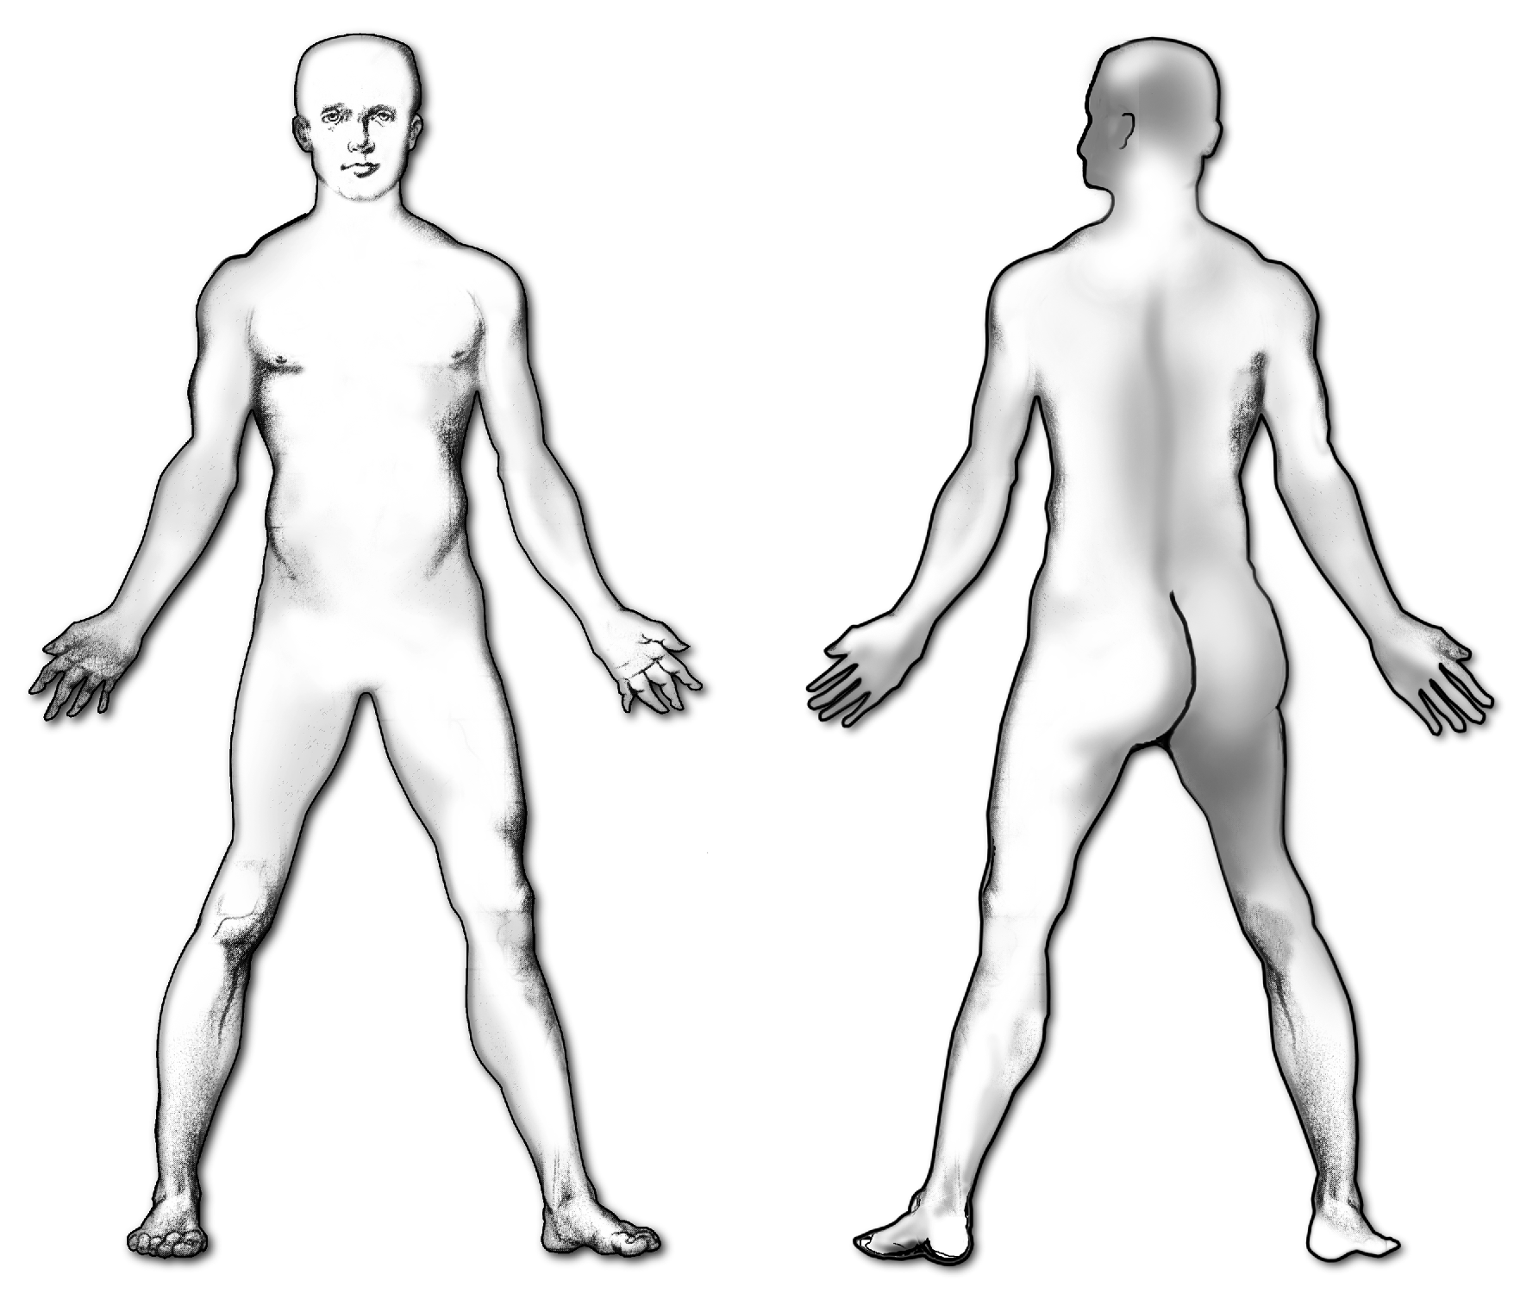

Cardiovascular

Digestive

Excretory

Nervous

Respiratory

# Cost of Injury

|  |  |  |  |
| --- | --- | --- | --- |
| Lost Work____________________ | Restricted Work _________ | | Total Days ____________ |
| Support Worker(s) Required _____ | Total Number ___________ | | Lost Wages ___________ |
| First Aid Supply/Disposal Costs _____________________________ | | | Down Time ___________ |
| Employee/Family Compensation ____________________________ | | | Legal Costs ___________ |
| Equipment Damage Costs _______________________ | | Product/Raw Material Lost ________ | |
| Training and Retraining Cost  ________ | | Worker Compensation ____________ | |

# Medical Treatment Rendered

|  |  |  |
| --- | --- | --- |
| Date/Time/Type of Treatment _____________________________________________________ | | |
| Health Professional Visit Required Yes No Injury Illness  New Old | | |
| Length of Visit ______hr/day(s) | Cost of Total Visit ________ | Rehabilitation Yes No |

Temporary Precaution to Take _____________________________________________________

______________________________________________________________________________

Corrective Actions Taken (Engineering, Administrative, PPE, and Other) ___________________

______________________________________________________________________________

Was the information interactively discussed with all affected staff? Yes No

Management’s Response _________________________________________________________

______________________________________________________________________________