The individual who uses a tight-fitting respirator is to perform a user seal check to ensure that an adequate seal is achieved each time the respirator is put on. Either the positive and negative pressure checks listed in this appendix, or the respirator manufacturer’s recommended user seal check method shall be used. User seal checks are not substitutes for qualitative or quantitative fit tests.

I. Facepiece Positive and/or Negative Pressure Checks
a. | Positive pressure check. Close off the exhalation valve and exhale gently into the facepiece. The face fit is considered satisfactory if a slight positive pressure can be built up inside the facepiece without any evidence of outward leakage of air at the seal. For most respirators this method of leak testing requires the wearer to first remove the exhalation valve cover before closing off the exhalation valve and then carefully replacing it after the test. | 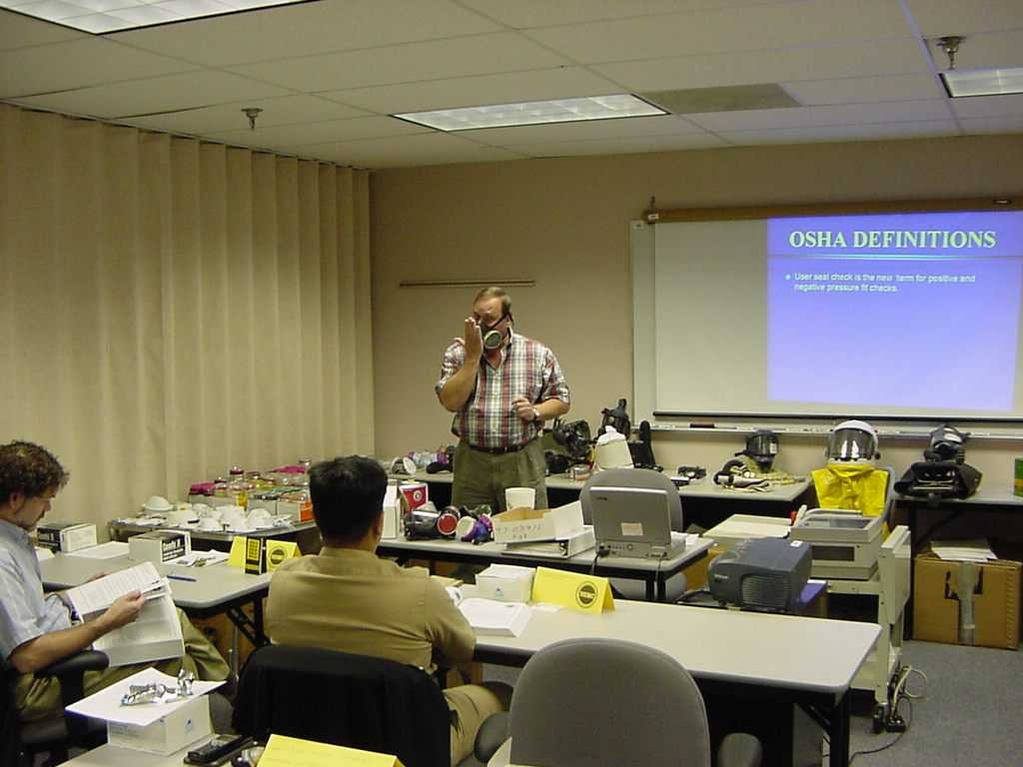
b. | Negative pressure check. Close off the inlet opening of the canister or cartridge(s) by covering with the palm of the hand(s) or by replacing the filter seal(s), inhale gently so that the facepiece collapses slightly, and hold the breath for ten seconds. The design of the inlet opening of some cartridges cannot be effectively covered with the palm of the hand. The test can be performed by covering the inlet opening of the cartridge with a thin latex or nitrile glove. If the facepiece remains in its slightly collapsed condition and no inward leakage of air is detected, the tightness of the respirator is considered satisfactory. | 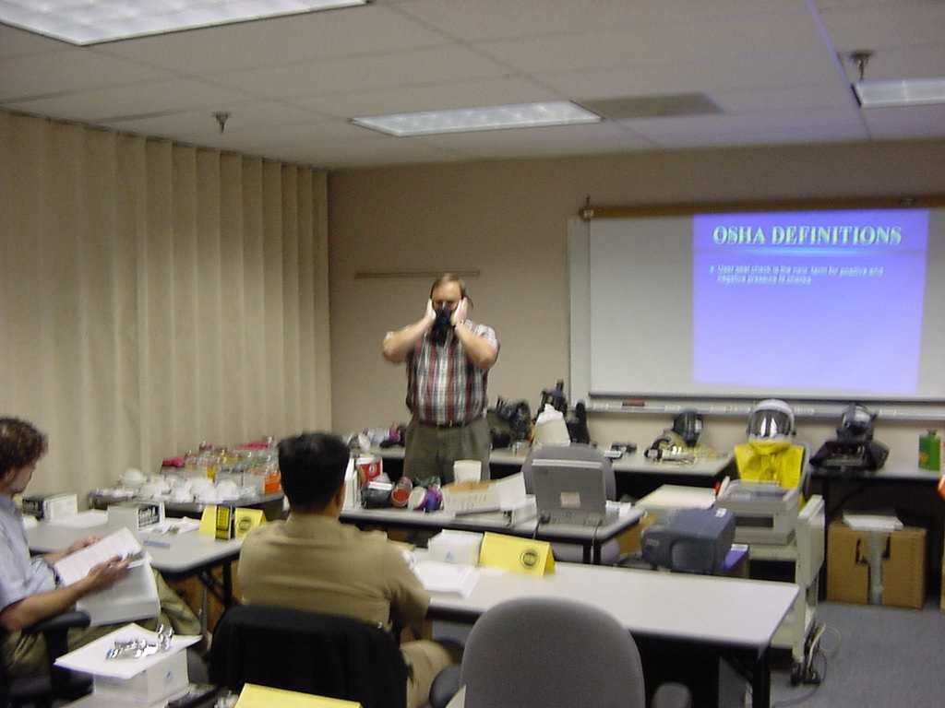
II. Manufacturer’s Recommended User Seal Check Procedures

The respirator manufacturer’s recommended procedures for performing a user seal check may be used instead of the positive and/or negative pressure check procedures provided that the in2vate’s Safety Coordinator demonstrates that the manufacturer’s procedures are equally effective.

