Your Company  Note: This is a 240  Volt Machine,  Arc Flash  Equipment may be  Required |  |  |  | Neutral Energy State for Lockout/Tagout
 |  |  |  | Work Center | Machine Name |  |  | Sheet
 |  |  |  | Machine Shop | OKUMA LB25  ID # _______ |  |  | 1 of 3
 |  |  |  | PPE | LOTO Gear |  |  | Revision Date
 |  |  |  | 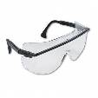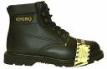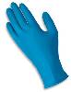 | 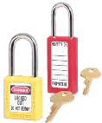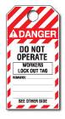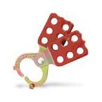 |  |  | 8/1/07
Work Sequence | Element Description | Steps | Operating Instructions |  |  |  | Visual Depictions
1 | Operators Requirement  Equipment Shutdown | 1a | Notify all affected personnel (operators of machine/equipment, etc.) that LOTO procedures are in Effect, then Press the Large Red Stop Button. |  |  |  | 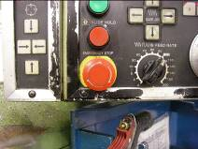  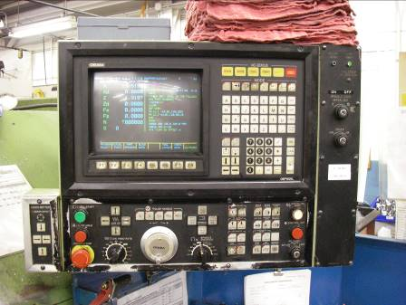
 | Operators Requirement | 1b | Turn Rotating on/off Switch to the left so that it sits in the off position. |  |  |  | 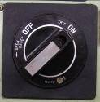  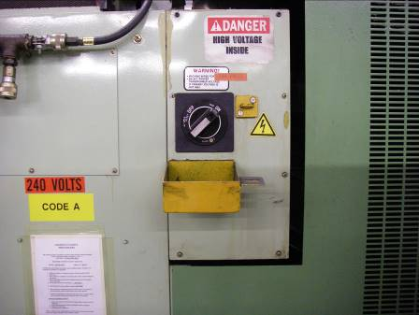
2 | Maintenance Staff  Apply LOTO Devices | 2a | Raise Yellow LOTO Cover so it fully covers on/off switch. |  |  |  | 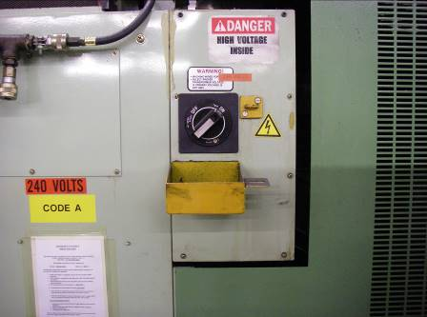  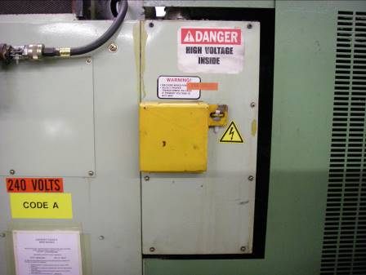
 | Maintenance Staff | 2b | Lock Yellow Box with LOTO Lock and Lockout Card. |  |  |  | 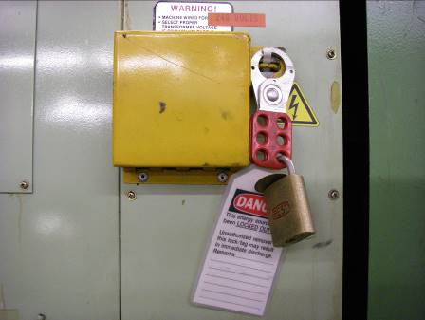
3 | Maintenance Staff  Release All Hazardous Energy Sources | 3a | Once Machine power has been turned off and locked out, all Hazardous Energy Sources should be evaluated and Controlled – follow service and maintenance analysis form
4 | Maintenance Staff  Verify Machine/Equipment Is In A Zero Mechanical State (ZMS) | 4a | Make sure the pressure gauges read zero pressure. |  |  |  | 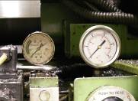  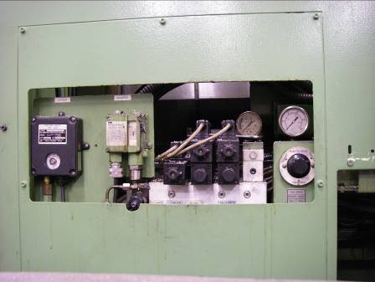
 | Maintenance Staff | 4b | Test that the machine is at a zero energy state. Turn knob so arrows points up and Push knob, the Pressure Gauge above it should read zero. |  |  |  | 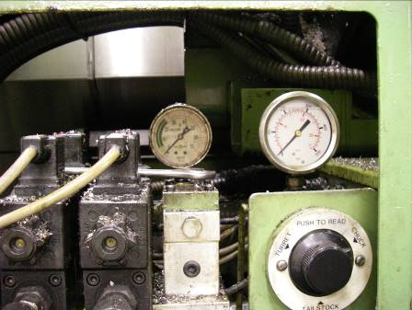
5 | Maintenance Staff  Service machine | 5a | Carry out Service needs.
6 | Maintenance Staff  Re-energizing Equipment/Machine | 6a | Make sure machine/equipment is in good working order.
 | Maintenance Staff | 6b | Notify all affected personnel that LOTO devices are going to be removed from equipment/machinery and all personnel is safely positioned away from the equipment/machinery.
 | Maintenance Staff | 6c | Check for and retrieve all loose tools, equipment/machine parts. Reinstall all removed.
 | Maintenance Staff | 6d | Remove all LOTO devices from energy isolating devices. |  |  |  | 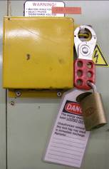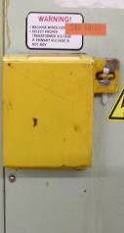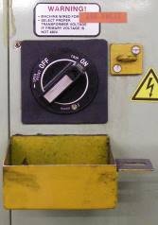
 | Operator Requirement | 6e | Re-energize machine, Turn the black on/off Knob to the right so it reads ON, and Press the White Control ON/Reset Button. |  |  |  | 